Triangle Problem.
Theorem
Mark six points (A, B, C, D, E, F) on a piece of paper so that no three points are in a straight line.
Join each pair of points with a straight line. Colour each line red or green.
However you choose to colour the lines, there will always be a triangle with 3 red lines or a triangle with 3 green lines.
Proof
A is connected to 5 lines and each line is either red or green.
either: A is connected to 3 (or more) red lines
or: A is connected to 3 (or more) green lines
Consider the case where A is connected to 3 (or more) red lines, say AB, AC and AD.

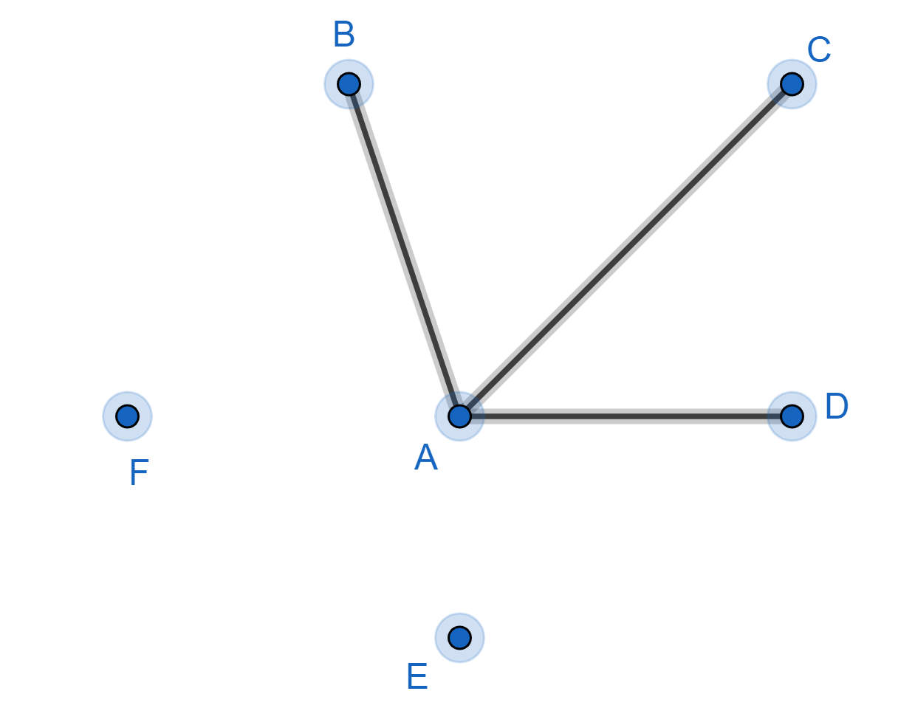

If line BC is red then triangle ABC has 3 red lines
If line CD is red then triangle ACD has 3 red lines
If line BD is red then triangle ABD has 3 red lines
If lines BC, CD, BD are all green then triangle BCD has 3 green lines
We can repeat this argument if A connected to 3 (or more) green lines.
Either way, we have the required triangle.

